Supplemental Digital Content 7
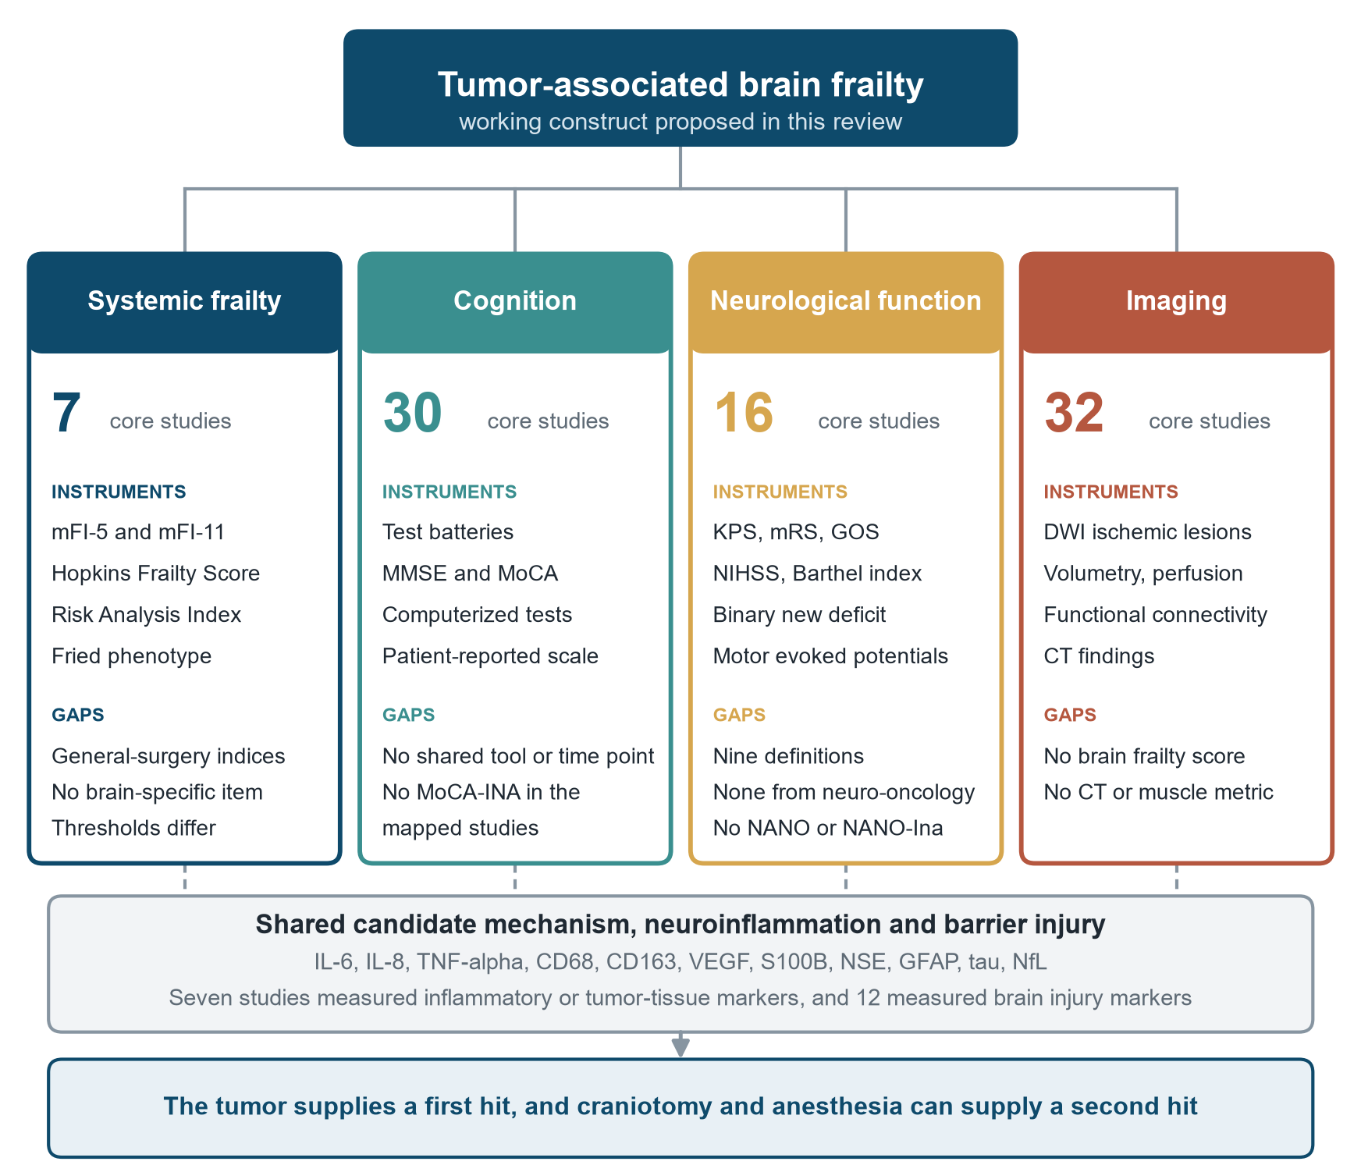
Figure. Four candidate domains of tumor-associated brain frailty, with the number of core studies, instruments identified, and gaps, above the shared candidate mechanism of neuroinflammation and barrier injury. IL, interleukin. TNF, tumor necrosis factor. VEGF, vascular endothelial growth factor. NSE, neuron-specific enolase. GFAP, glial fibrillary acidic protein. NfL, neurofilament light chain. mFI, modified frailty index. MMSE, Mini-Mental State Examination. MoCA, Montreal Cognitive Assessment. KPS, Karnofsky Performance Status. NIHSS, National Institutes of Health Stroke Scale. mRS, modified Rankin Scale. GOS, Glasgow Outcome Scale. NANO, Neurologic Assessment in Neuro-Oncology. DWI, diffusion-weighted imaging.

